<!--This file created 2:29 PM 10/29/97 by Claris Home Page version 2.0-->2.2 Project
Limits, Slopes, and Logarithms

This project calls for numerical investigation of the limit

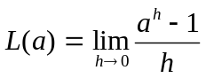 (1)

where a is a positive constant. If we write 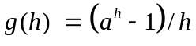 then we want to
investigate the value of the limit
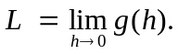 (2)

For this purpose, we calculate the value 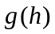 for a sequence of different values of h approaching zero, and ask what fixed number L (if any) these values appear to approach. Particularly if the same apparent limit L results with different zero-approaching sequences of h-values, then this "apparent limit" is a good (though not certain and sure-fire) candidate for the actual limit in (1).
To manufacture a sequence of zero-approaching h-values to use for this purpose,
we select both an initial (fixed) value h and a "divisor" p > 1. We then calculate the function values
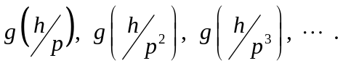 (3)

Note that each new h-value here is gotten by dividing the previous one by p. For instance,
choosing a = 10, initial increment h = 1, and divisor p = 4, we proceed to calculate the values

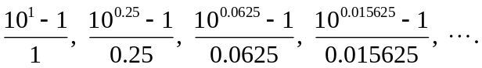

We assemble our numerical results in a table of values convenient for visual inspection.

h | 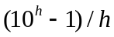
0.250000 | 3.1131
0.062500 | 2.4765
0.015625 | 2.3445
0.003906 | 2.3130
0.000977 | 2.3052
0.000244 | 2.3032
0.000061 | 2.3027
0.000015 | 2.3026
0.000004 | 2.3026
0.000001 | 2.3026

Scanning down the second-column values in this table, we infer that

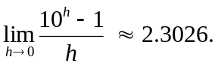

Our numerical evidence, though highly suggestive, does not actually prove it. But, in fact, it is known that

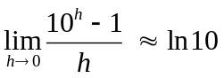

(the "natural" logarithm of 10) and you can use the 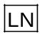 key on your calculator to verify that ln 10 = 2.3026 accurate to 4 decimal places.

Now pick a random pair of positive integers a and b, and investigate the numerical values 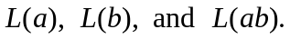 See whether your results are consistent with the fact that
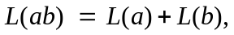 (4)

in analogy with the law of logarithms

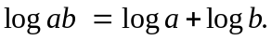 (5)

At this point the connection between Eqs. (4) and (5) is surely an enigma rather than an explanation. The mystery will be explained in Section 3.8 when we study "natural logarithms". For now, use the key on your calculator to find ln a, ln b, and ln ab; compare these with your values You might also use a computer algebra system to attempt to evaluate the limit in (1) symbolically, and then compare the symbolic result with your numerical results.

Using a Graphing Calculator
The calculator screen on the next page shows a TI-83 prepared to estimate the limit

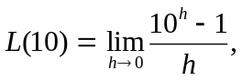 (6)
starting with the initial increment h = 1.

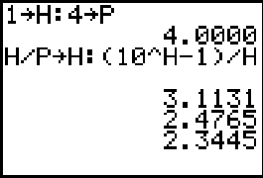

Each successive press of the  key divides the current value of the increment h by the divisor p = 4 and then re-calculates the quotient in (6):

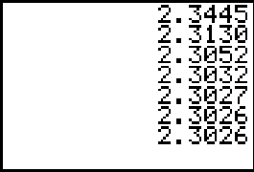

Ultimately we obtain all the values shown in our original table, which indicate that L(10) = 2.3026 accurate to 4 decimal places.
NOTE: With this approach it's good practice to always use at least two different sequences of zero-approaching h-values to investigate a given limit, making sure that each indicates the same limit. With negative values of p you can use values of x that are both above and below the limiting value a of x.
For instance, starting with h = 0.2 and p = –7, a similar calculation yields a sequence of values alternately greater than and less than the limiting value 2.3026,
and apparently converging to this limit a bit faster than with p = 4. (See the two screens at the top of the next page.)

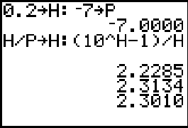
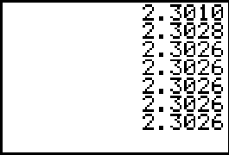

Using Maple

First let's define the function 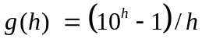 by

g := h -> (10^h - 1)/h;

Then with initial increment and divisor

h := 1; p := 4;

we calculate the table of values

for k from 1 by 1 to 10 do
print(evalf(h/p^k,15),evalf(g(h/p^k),15)) od;

.250000, 3.113118
.062500, 2.476512
.015625, 2.344507
.003906, 2.312971
.000977, 2.305176
.000244, 2.303232
.000061, 2.302747
.000015, 2.302626
.000004, 2.302596
.000001, 2.302588

(We have calculated accurate to 15 digits but rounded off the output to 6 decimal places.)
Thus we obtain the values shown in our original table, which indicate that L(10) = 2.3026 accurate to 4 decimal places.
NOTE: With this approach it's good practice to always use at least two different sequences of zero-approaching h-values to investigate a given limit, making sure that each indicates the same limit. With negative values of p you can use values of x that are both above and below the limiting value a of x.
For instance, starting with h = 1 and p = –7, a similar calculation yields a sequence of values alternately greater than and less than the limiting value 2.3026,
and apparently converging to this limit a bit faster than with p = 4.

h := 1; p := -7;
for k from 1 by 1 to 9 do
print(evalf(h/p^k,15),evalf(g(h/p^k),15)) od;

-.14285714, 1.962200
.02040816, 2.357544
-.00291545, 2.294874
.00041649, 2.303690
-.00005958, 2.302427
.00000850 , 2.302608
-.00000121, 2.302582
.00000017, 2.302586
-.00000002, 2.302585

Using Mathematica

First let's define the function by

g[h_] := (10^h - 1)/h

Then with initial increment and divisor

h := 1; p := 4;

we calculate first a list of successive h-values

H = Table[ h/p^k, {k,1,10} ]

{0.25, 0.0625, 0.015625, 0.00390625, 0.000976563,
0.000244141, 0.0000610352, 0.0000152588, 3.8147*10⁻⁶,
9.53674*10⁻⁷}

and then the list of corresponding values of g(h):

g[H] // TableForm

3.11312
2.47651
2.34451
2.31297
2.30518
2.30323
2.30275
2.30263
2.3026
2.30259

Thus we obtain the essentially the same values shown in our original table, which indicate that L(10) = 2.3026 accurate to 4 decimal places.
NOTE: With this approach it's good practice to always use at least two different sequences of zero-approaching h-values to investigate a given limit, making sure that each indicates the same limit. With negative values of p you can use values of x that are both above and below the limiting value a of x.
For instance, starting with h = 0.2 and p = –7, a similar calculation yields a sequence of values alternately greater than and less than the limiting value 2.3026,
and apparently converging to this limit a bit faster than with p = 4.

h = 1.; p = -7;
H = Table[ h/p^k, {k,1,8} ];
g[H] // TableForm

1.9622
2.35754
2.29487
2.30369
2.30243
2.30261
2.30258
2.30259

Using MATLAB

First let's define the function by

g = inline('(10.^h - 1)./h')

Then with initial increment and divisor

h := 1; p := 4;

we calculate first a list of successive h-values

H = h ./ p.^[1 2 3 4 5 6 7 8 9 10];

and then the list of corresponding values of g(h):

g(H)'
ans =
3.1131
2.4765
2.3445
2.3130
2.3052
2.3032
2.3027
2.3026
2.3026
2.3026

Thus we obtain the essentially the same values shown in our original table, which indicate that L(10) = 2.3026 accurate to 4 decimal places.
NOTE: With this approach it's good practice to always use at least two different sequences of zero-approaching h-values to investigate a given limit, making sure that each indicates the same limit. With negative values of p you can use values of x that are both above and below the limiting value a of x.
For instance, starting with h = 1 and p = –7, a similar calculation yields a sequence of values alternately greater than and less than the limiting value 2.3026,
and apparently converging to this limit a bit faster than with p = 4.

h = 1; p = -7;
H = h ./ p.^[1 2 3 4 5 6 7 8 9 10];
g(H)'
ans =
1.9622
2.3575
2.2949
2.3037
2.3024
2.3026
2.3026
2.3026
2.3026
2.3026

